SC Formula Electric
11/12/25

Precharge Documentation

Description:

The precharge board waits for the car to be ready to precharge - shutdown circuit is good - before starting precharge. Then it will track the voltage at two points of the circuitry, ensuring that it is neither precharging too slow or too fast. These voltage values are obtained by measuring the frequency of a PWM generated by a voltage-frequency convertor. Generally, we want the second point to reach 90% of the first point’s voltage by a few seconds. If this does not occur, the board will go into an error state. If it does occur, then the car is done precharging, and it will open a relay that allows the car to fully charge.

Hardware info:
Board layout
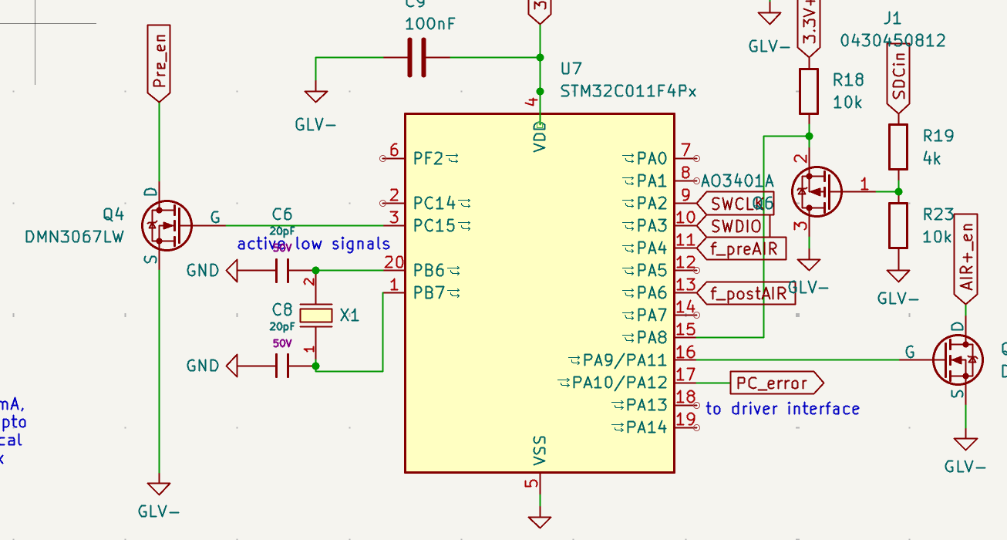
- PA10/12 = output to Error
- PA9/11 = output to change relay for charging
- PA8 = input from SDC (high = BAD, low = GOOD)
- PC15 = output to indicate precharging
- PA4 = PWM input of first point
- PA6 = PWM input of first point

Frequency-Voltage convertor
https://www.ti.com/lit/ds/snosbi2c/snosbi2c.pdf

Software info:

TIM16 - interrupts at rising edge of PWM for pin 6 / post freq
- Callback:
  - Stores 2 counts of when the interrupt gets called -> 1 period
  - Calculates the frequency based on those counts

TIM17 - interrupts at rising edge of PWM for pin 7 / pre freq
- Callback:
  - Stores 2 counts of when the interrupt gets called -> 1 period
  - Calculates the frequency based on those counts

TIM14 - clock that gets activated once in precharge state
- Using prescalar of 4096 for a 8MHz clock
- Callback:
  - Checks the ratio of frequencies at two time points: 0.05 sec and 1 sec
  - If ratio is >90% or <90% at respective time points -> error state
  - Else, done precharging

States:
Reset state:

start_flag = 0
charge_flag = 0

OUTPUTTING -
AIR_EN = 0
PRE_EN = 0
PC_ERR = 0

If SDC_Pin goes from high to low
Precharge state:

start_flag = 1
charge_flag = 0

Start all timers

OUTPUTTING -
AIR_EN = 0
PRE_EN = 1
PC_ERR = 0

Error state:

error_flag = 1
start_flag = 0
charge_flag = 0

OUTPUTTING -
AIR_EN = 0
PRE_EN = 0
PC_ERR = 1
If error_flag = 1
Charged state:

start_flag = 0
charge_flag = 1

OUTPUTTING -
AIR_EN = 1
PRE_EN = 0
PC_ERR = 0
If charge_flag = 1 and start_flag = 0

If SDC_Pin = 1

If SDC_Pin = 1

Timers checking

